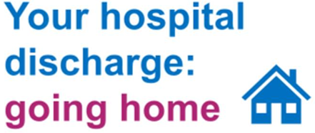

This leaflet explains why you are being discharged from hospital an what you might expect after your discharge.

**Why am I being discharged from hospital?**

You are being discharged from hospital as your health team have agreed that you are now able to return home.

**Why can’t I stay in hospital?**

The health system is busy helping patients affected by coronavirus (COVID-19). This is a new illness that can affect the lungs and airways and some people who contract the illness will need to be admitted to hospital. It is important that our hospitals are ready to look after those people who need this hospital care.

Because of this, you will not have a choice over your discharge. You will not be able to remain in hospital if you choose not to accept the care that is being offered to you.

**What can I expect?**

It is our priority to ensure that you are discharged safely from hospital and to the most appropriate available place.

Your health team will discuss discharge and transport arrangements with you (and a family member, friend or carer if you wish). If you require care and support when you get home, this will be arranged.

Any care provided will be free of charge for a period of time to support your recovery. After this time you may be required to contribute to the cost of your care.

**Who can I contact?**

After you have been discharged, if you have any concerns or need to speak to someone about your care you can contact <insert locally agreed details e.g. team name & contact number)

**To find out more about coronavirus (COVID-19) and find out how to avoid catching or spreading it, visit www.nhs.uk/coronavirus**