27th March 2020

Dear Sir/Madam

This letter is sent to you by Help to Buy Wales Ltd.
Help to Buy Wales is introducing a temporary repayment holiday arrangement for its customers who are making interest repayments, and who may suffer financial hardship as a result of the Coronavirus outbreak, of up to three months.
If you are currently making interest payments under your Equity Share loan agreement, you can request a temporary interest repayment holiday using the request form at the end of this letter. You can do this by emailing a copy of this letter back to us, with the request completed. Alternatively, you can type the completed request wording into an email and send it to us at cr@helptobuywales.co.uk

In either case, we will need to receive your completed request no later than 30th June 2020. If we do so, we will then suspend your monthly interest payments for a period of up to three months.

The terms of this repayment holiday would be as set out below;

- This repayment holiday would only apply to monthly interest payments falling due during the period requested after we receive and process your request. Please bear in mind that it may take a few days for your request to be processed. Accordingly, if you only make your request shortly before a payment is due, you should not assume that the repayment holiday will apply to that payment.

- The £1 monthly management fee would continue to be taken by direct debit during the interest repayment holiday.

- This arrangement would be entirely concessionary. The contractual terms of your loan agreement would be unaffected, and the unpaid sums would strictly be 'arrears'.

- However, provided that you continued to comply with all the other terms of your loan agreement, we would not take steps to enforce payment of these arrears, but would allow them to be deferred and repaid when you make repayment/part repayment of the loan itself.

It is important that you appreciate that if you request a repayment holiday and your loan agreement is regulated by the Consumer Credit Act 1974, we would be obliged by law to send you 'arrears notices' from time to time.

On the other hand, the fact that your loan agreement would be in arrears as a result of a Covid -19 repayment holiday would not be made public and would not affect your credit history.

Accordingly, should you at any time decide that you are able to repay these arrears earlier, please contact us to do so.

Yours faithfully
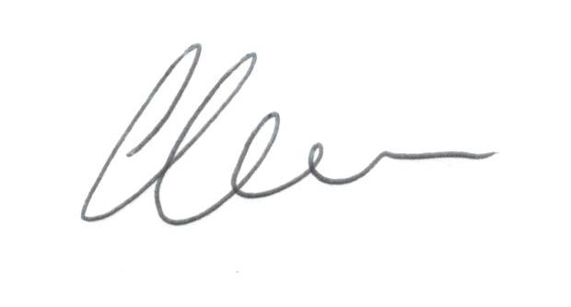
Joseph Clare
Customer Relations Manager
Help to Buy (Wales)

REQUEST FOR A COVID-19 REPAYMENT HOLIDAY

I/we request a [one/two/three]* month repayment holiday under my/our Equity Share loan on the terms set out in your letter of 27th March 2020.
*please delete as appropriate
HTBW reference__________________________

Party Name 1: ___________________________ Party Name 2: _______________________________

Signed: ___________________________ Signed: _______________________________

Date: ___________________________ Date: _______________________________

Please note that where two borrowers are subject to the terms of our equity loan, both parties must provide confirmation in all cases.

If you do not have scanning facilities, you can type the above wording into
an email and send it to us at cr@helptobuywales.co.uk

