Iaith Athrawon Yfory 2018-19  Form IAY 2018-19 – Qualified Teacher Status | 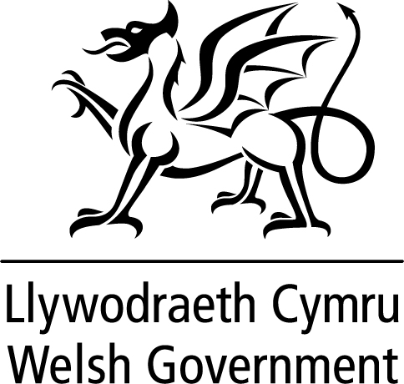
This form confirms that the student teacher has completed a postgraduate secondary initial teacher education course and successfully gained Qualified Teacher Status (QTS) during the 2018-19 academic year
Claimant Details
Full Name
Address
Postcode
Date of birth |  | Student Number

Programme Details
Programme studied
Course provider

Amount of
£
WMIS grant received

Declaration by Initial Teacher Education Provider
I confirm that the above trainee has undertaken the Welsh Medium Improvement Scheme (WMIS) in academic year 2018-19.
Signature: | Date:
Name | Job title:
I confirm that the above trainee has undertaken the above postgraduate secondary programme during academic year 2018-19 and successfully obtained QTS to enable them to teach through the medium of Welsh.
Signature: | Date:
Name | Job title:

Note: A false declaration may result in any grant paid being reclaimed
Guidance on the eligibility criteria for claiming the Iaith Athrawon Yfory incentive is given in “Iaith Athrawon Yfory Incentive Scheme – Academic Year 2018-19: guidance notes for claimants & providers”.

I confirm that I have read and understood the above guidance (please √ to confirm)

1.1 Qualified Teacher Status Details
Date QTS completed

1.2 Trainee Declaration
I am claiming the incentive - £500
I received the £2000 WMIS grant in academic year 2018-19
I authorise the Welsh Government to pay this into the account details provided on the PL8. I confirm that :-
- I trained in an eligible postgraduate secondary programme during academic year 2018-19
- I am now able to teach through the medium of Welsh
- I have successfully obtained QTS and attach a copy of my QTS certificate.

Signature of teacher: |  | Date:
Name in block capitals

Note: A false declaration may result in any incentive paid being reclaimed

As you are in receipt of grant funding from the Welsh Government we need to make you aware that we may share any data you provide to us with fraud prevention agencies and third parties for the purposes of preventing and detecting fraud.

In order for us to comply with the fair processing principle of data protection we need to advise you how your personal data maybe used.

The information we have collected from you will be shared with fraud prevention agencies who will use it to prevent fraud and money-laundering and to verify your identity. If fraud is detected, you could be refused certain services, finance or employment in future. Further details of how your information will be used by us and these fraud prevention agencies, and your data protection rights, can be found by contacting Data.ProtectionOfficer@gov.wales

Further information is available at http://gov.wales/docs/caecd/publications/171113-fair-process-en.pdf

Completed claim forms and scanned copy certificates to be sent in a secure format to ITEIncentives@gov.wales

I confirm that I have read and understood the Welsh Government privacy notice.

Your personal details will only be used for the purpose of monitoring ITE incentives. We will not share them with any other stakeholders.

