Easy Read

How we deliver autism services in Wales
Response Form
Please tell us what you think by 14 December 2020

This is an easy read version of the questions from Welsh Government’s ‘Code of Practice on the Delivery of Autism Services’ – Consultation Document 2020.
September 2020

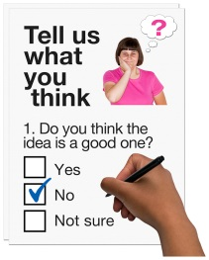
How to fill in this response form
This response form has questions about our Code of Practice for autism services.
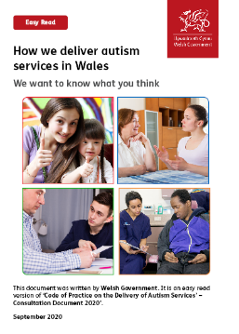

Before you answer the questions, please read the main easy read document: How we deliver autism services in Wales. September 2020.

Please try to explain your answers. And give your own thoughts and ideas too.

You may need support to read and understand this document. Ask someone you know to help you.
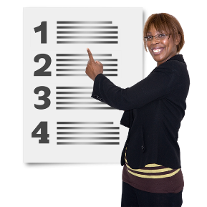

Words in blue writing may be hard to understand. They have been explained on page 38 of the main easy read document.

Where the document says we, this means Welsh Government.
This document was made into easy read by Easy Read Wales using Photosymbols.

Please send this form back to us by 14 December 2020.

By post: Autism Policy Branch
Welsh Government
Cathays Park
Cardiff
CF10 3NQ
By email: Autism.CodeofPracticeConsultation@gov.wales

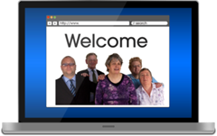
Or you can fill in the response form on our website:

How we will use the information you give us
Welsh Government will be looking at your answers in this response form.

Sometimes we ask other organisations to help us make decisions. They may also see the answers that people gave in the response forms.
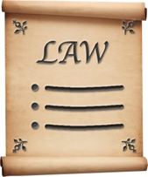
We will make sure we follow the law when we use your information.
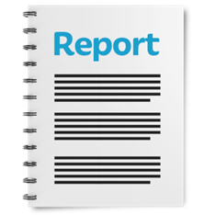

We will write a report about what people said.

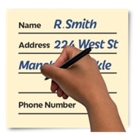
We might write some people’s answers in full, with their names and addresses in the report or on the internet.
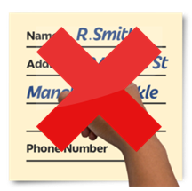
When you send us your answers, please tell us if you do not want us to write your name and address in the report or on the internet.
The data protection laws give you the right to:
- Know what information we have about you and how you can see it.

- Make us change any mistakes in the information about you.

- Ask us not to use the information in some cases.

- Ask us to delete the information we have about you in some cases.

- Move the information about you somewhere else in some cases.

- Complain to the Information Commissioner’s Office.
If you would like to know more about how your information is kept and used please contact us at:
Data Protection Officer
Welsh Government
Cathays Park
CARDIFF
CF10 3NQ
Email: Data.ProtectionOfficer@gov.wales
You can also contact the Information Commissioner’s Office:
Wycliffe House
Water Lane
Wilmslow
Cheshire
SK9 5AF
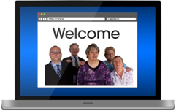
Tel: 01625 545745 or 0303 123 1113
Website: https://ico.org.uk

About you
Your name:

The organisation you are answering for:

Your email address:

Your home address:

Do you want your name and address on the answers we send out?

Yes | ☐ |  | No | ☐

Questions

- Do you agree with the definition of autism used within this Code?

Yes | ☐ | I think so | ☐ | I do not think so | ☐ | No | ☐

If you do not agree with the definition, please explain why not:

- Do you agree that the Code should focus on autism services only? Or do you think it should cover other things like ADHD as well?

Yes | ☐ | I think so | ☐ | I do not think so | ☐ | No | ☐

If you do not agree with the definition, please explain why not:

Assessment and diagnosis

Please look at section 1 ‘Assessment and diagnosis’ on pages 8 to 13 of the easy read document.

3a. Are the duties in this section right for both services and autistic people? Please tick 1 box.

Yes | ☐ | I think so | ☐ | I do not think so | ☐ | No | ☐

Please explain why you think this:

Do you think anything is missing?

3b. Do you think it is clear how assessment and diagnosis should be organised?
Yes | ☐ | I think so | ☐ | I do not think so | ☐ | No | ☐

Please explain why you think this:

How people get health and social care support

Please look at section 2 ‘How people get health and social care support’ on pages 14 to 25 of the easy read document.

4a. Are the duties in this section right for both services and autistic people? Please tick 1 box.

Yes | ☐ | I think so | ☐ | I do not think so | ☐ | No | ☐

Please explain why you think this:

Do you think anything is missing?

4b. Do you think it is clear how people get care and support services?

Yes | ☐ | I think so | ☐ | I do not think so | ☐ | No | ☐

Please explain why you think this:

Raising awareness and training
Please look at section 3 ‘Raising awareness and training’ on pages 26 to 32 of the easy read document.

5a. Are the duties in this section right for both services and autistic people? Please tick 1 box.

Yes | ☐ | I think so | ☐ | I do not think so | ☐ | No | ☐

Please explain why you think this:

Do you think anything is missing?

5b. Is this section clear about raising awareness and training?

Yes | ☐ | I think so | ☐ | I do not think so | ☐ | No | ☐

Please explain why you think this:

Planning and checking services and involving people
Please look at section 4 ‘Planning and checking services and involving people’ on pages 33 to 37 of the main easy read document.

6a. Are the duties in this section right for both services and autistic people? Please tick 1 box.

Yes | ☐ | I think so | ☐ | I do not think so | ☐ | No | ☐

Please explain why you think this:

Do you think anything is missing?
6b. Do you think it is clear about how services should be planned and checked?

Yes | ☐ | I think so | ☐ | I do not think so | ☐ | No | ☐

Please explain why you think this:

6c. Do you think what we said about involving autistic people and family and carers is right for people and services?

Yes | ☐ | I think so | ☐ | I do not think so | ☐ | No | ☐

Please explain why you think this:

Is there anything missing?

Other questions
We want to know if our ideas for this Code of Practice will impact on protected groups of people. For example:
- People of different ages
- Disabled people
- Pregnant women
- People with different religions or beliefs
- Men and women.

- Do you think our ideas will have any good impacts on protected groups?

- Do you think our ideas will have any bad impacts on protected groups?

- Do you think our ideas will have any effect on the Welsh language?

For example do you think they will give people a chance to use Welsh? Do you think our ideas treat Welsh the same as English?

- Do you have any ideas about:
  - How the Code of Practice could help give people the chance to use Welsh?
  - How we can make sure we treat Welsh the same as English?
  - How we can make sure our ideas do not have a bad effect on the Welsh language?

- Is there anything else you would like to say?

Thank you.

