Easy Read

Chapter 31 of the draft Additional Learning Needs Code
Response form
Please send this response form back to us by
29 October 2020

This is an easy read version of the questions from the Welsh Government consultation on chapter 31 of the draft ALN Code: Representatives for young people, and parents of children, lacking mental capacity.
September 2020
How to fill in this response form
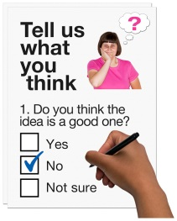
These questions are about our ideas for Chapter 31 of the Additional Learning Needs Code.

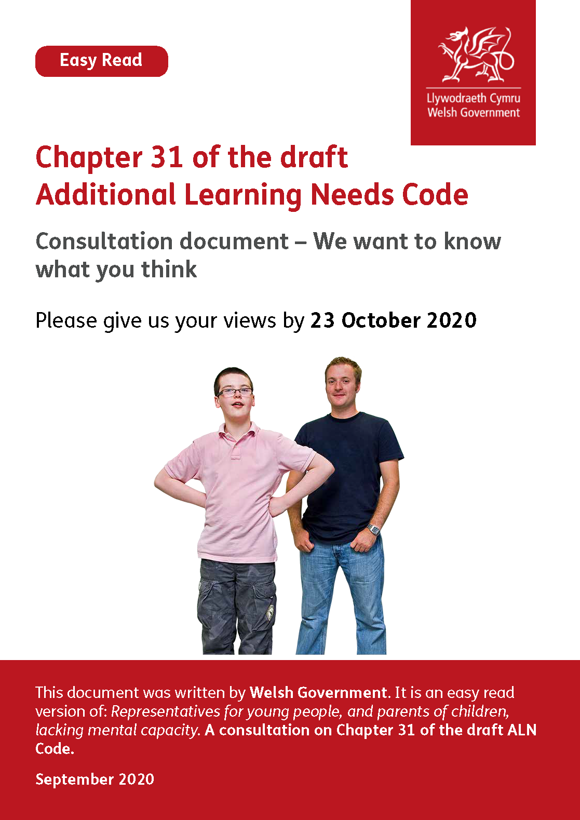
Before you answer the questions please read the main easy read document:

Chapter 31 of the draft Additional Learning Needs Code: Consultation document – We want to know what you think.

Please try to explain your answers. And give your own thoughts and ideas too.

You may need support to read and understand this document. Ask someone you know to help you.

Some words may be difficult to understand. These are in bold blue writing. They have been explained on page 12 of the main document.

Where the document says we, this means the Welsh Government.

This document was made into easy read by Easy Read Wales using Photosymbols.

October

Please send this form back to us by 23 October 2020.

By post:
Additional Learning Needs Transformation Branch
Support for Learners Division
The Education Directorate
Welsh Government
Cathays Park
Cardiff
CF10 3NQ
By email: SENreforms@gov.wales

How we will use the information you give us
Welsh Government will be looking at your answers to make decisions about Chapter 31 of the ALN Code.

Sometimes we ask other organisations to help us make decisions. They may also see the answers that people give.

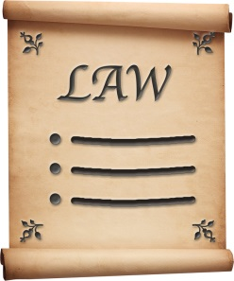
We will make sure we follow the law when we use your information.

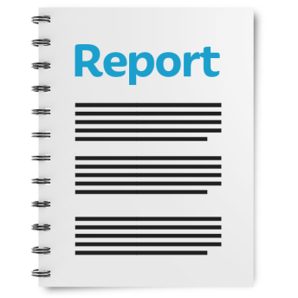

We will write a report about what people said.

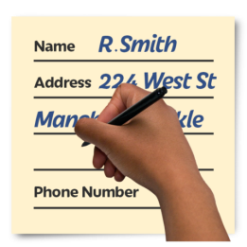
We might write some people’s answers in full with their names and addresses in the report or on the internet.
When you send us your answers, please tell us if you do not want us to write your name and address in the report or on the internet.

The data protection laws give you the right to:

- know what information we have about you and how you can see it

- make us change any mistakes in the information about you

- ask us not to use the information in some cases

- ask us to delete the information we have about you in some cases

- move the information about you somewhere else in some cases

- complain to the Information Commissioner’s Office.

If you would like to know more about how your information is kept and used please contact us at:

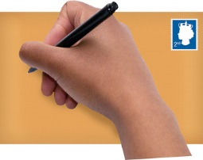
Data Protection Officer
Welsh Government
Cathays Park
Cardiff
CF10 3NQ

email: Data.ProtectionOfficer@gov.wales

You can also contact the Information Commissioner’s Office:

Wycliffe House
Water Lane
Wilmslow
Cheshire
SK9 5AF

Tel: 01625 545745 or 0303 123 1113

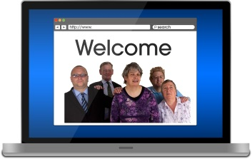
Website: https://ico.org.uk
Questions

Question 1. In the ALN Code we will write about the child’s parent.

In some cases, we want this to mean the child’s parent and their representative, if they have one.

But in most cases, when we write about a child’s parent, we want this to mean their representative, if they have one.

Do you think this would work ok?
Question 2. In the ALN Code we will write about the young person. Young people are people aged 16 to 25 years old.

In some cases, we want this to mean the young person and their representative, if they have one.

But in most cases, when we write about a young person, we want this to mean their representative, if they have one.

Do you think this would work ok?

Question 3. Do you think it is ok for a parent to be the representative for their young person?

Question 4. Is there anything else you want to tell us about the ALN Code and Chapter 31? Please tell us in the box below.

Thank you.

