Easy Read Response Form

Our plan for clean air in Wales
Please tell us what you think by 10 March 2020
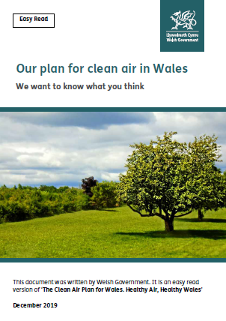

This document was written by Welsh Government. It is an easy read version of the questions from ‘The Clean Air Plan for Wales. Healthy Air, Healthy Wales’.
December 2019

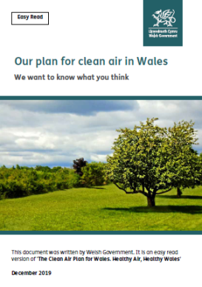
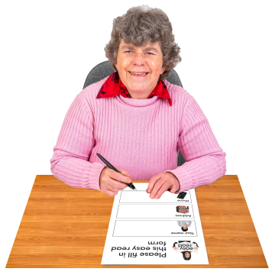
How to fill in this response form
These questions are about our plan for making air cleaner in Wales.

Before you answer the questions, please read the main easy read document: Our plan for clean air in Wales.

We want to know what you think. Please try to explain your answers. And give your own thoughts and ideas too.

You may need support to read and understand this document. Ask someone you know to help you.

Words in blue writing may be hard to understand. You can find out what all the words in blue mean on page 18 of the main document.

Where the document says we, this means Welsh Government.

Please send this form back to us by 10th March 2020.

Address:
Air Quality Policy Team
Environment and Communities Division
Welsh Government
Cathays Park
Cardiff
CF10 3NQ

The response form is also on our website: www.gov.wales/consultations

And can be emailed back to us at:
AirQualityPolicy@Gov.Wales

How we use the information you give us
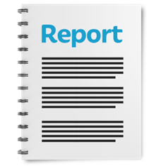
Welsh Government will be looking at your answers in this response form to make decisions about how to support people in the best way.

Sometimes we ask other organisations to help us make decisions. They may also see the answers that people gave in the response forms.

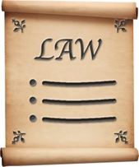
We will make sure we follow the law when you use your information.

We will write a report about what people said.

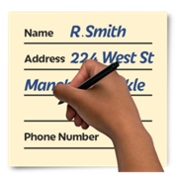
We might write some people’s answers in full with their names and addresses in the report or on the internet.

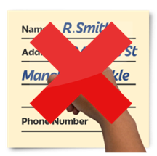
When you send us your answers, please tell us if you do not want us to write your name and address in the report or on the internet.

The data protection laws give you the right to:

- Know what information we have about you and how you can see it.

- Make us change any mistakes in the information about you.

- Ask us not to use the information in some cases.

- Ask us to delete the information we have about you in some cases.

- Move the information about you somewhere else in some cases.

- Complain to the Information Commissioner’s Office.
If you would like to know more about how your information is kept and used please contact us at:

Data Protection Officer
Welsh Government
Cathays Park
CARDIFF
CF10 3NQ
Email: Data.ProtectionOfficer@gov.wales

You can also contact the Information Commissioner’s Office:

Wycliffe House
Water Lane
Wilmslow
Cheshire
SK9 5AF
Tel: 01625 545745 or 0303 123 1113

Website: https://ico.org.uk

About you
Your name:

The organisation you are answering for or with:

Your email address:

Your address and phone number:

Do you want your answers to be shown on the internet and in a report?

Yes | ☐ |  | No | ☐

Questions

- Please read page 9 of the main document.

Is there anything else that should be included on the Air Quality in Wales website?

- Do you have any ideas for other ways people can learn about air quality issues?

- Please read pages 11 - 17 of the main document.

Do you think the 4 parts of our plan explain the main things we want to do?
Yes | ☐ | No | ☐ | Not sure | ☐

Is there anything you would like to say about this?

- Do you agree people should help to reduce air pollution?
Yes | ☐ | No | ☐ | Not sure | ☐

Is there anything else you would like to say about this?
- If you said yes to question 4, how do you think we should help people reduce the amount of air pollution they make?

- Please read pages 11, 12 and 13 of the main document.

Do you agree with the steps we want to take to lower air pollution to make people’s health and well-being better?
Yes | ☐ | No | ☐ | Not sure | ☐

Is there anything you would like to say about this?

- Do you think we have covered the most important actions to protect health and well-being?
Yes | ☐ | No | ☐ | Not sure | ☐

Is there anything you want to say about this?

- What would you like to happen in the area where you live to reduce air pollution?

- Who do you think should be in charge of the things you suggested in question 8?

- Please read pages 14 and 15 of the main document.

Do you agree with the steps we want to take to lower air pollution to support the environment and wildlife?
Yes | ☐ | No | ☐ | Not sure | ☐

Is there anything you would like to say about this?

- Do you think we have covered the most important actions to support the environment and wildlife?
Yes | ☐ | No | ☐ | Not sure | ☐

Is there anything you would like to say about this?

- Please read page 16 of the main document.

Do you agree with the steps we want to take to help make Wales a better off place?
Yes | ☐ | No | ☐ | Not sure | ☐

Is there anything you would like to say about this?

- Do you think we have covered the most important actions to make Wales a better off place?
Yes | ☐ | No | ☐ | Not sure | ☐

Is there anything you would like to say about this?
- Please read page 17 of the main document.
Do you agree with the steps we want to take to make Wales a better place to live?
Yes | ☐ | No | ☐ | Not sure | ☐

Is there anything you would like to say about this?

- How do you think we can help people use their cars less and use public transport and active ways to travel more?

- Do you think we have covered the most important actions to make Wales a better place to live?
Yes | ☐ | No | ☐ | Not sure | ☐

Is there anything you would like to say about this?

- Is there anything else you think we should include in our plan?

