Easy Read

Disabled Students’ Allowances
Please tell us what you think about the changes we want to make
Response form
Please tell us what you think by 17th February 2020

This is an easy read version of the Welsh Government Consultation Questions from Disabled Students’ Allowances.

October 2019 Number: WG33324

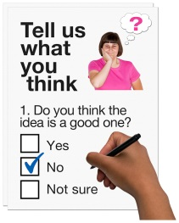
How to fill in this response form
These questions are about our ideas for changing Disabled Students’ Allowances.

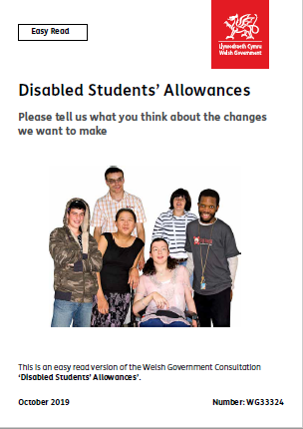
Before you answer the questions, please read the main easy read document: Disabled Students’ Allowances. Please tell us what you think about the changes we want to make.

Please try to explain your answers. And give your own thoughts and ideas too.

You may need support to read and understand this document. Ask someone you know to help you.

Some words may be difficult to understand. These are in blue writing and have been explained on page 20 of the main document.

Where the document says we, this means the Welsh Government.

Please send this form back to us by 17th February 2020

Address: Higher Education Division
Welsh Government
Cathays Park
Cardiff
CF10 3NQ

E-mail: HEDConsultationsMailbox@gov.wales

How we use the information you give us
We will look at your answers in this response form to help us make decisions about changing Disabled Students’ Allowances.

Sometimes we ask other organisations to help us make decisions. They may also see the answers that people gave in the response forms.

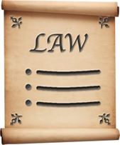
We will make sure we follow the law when you use your information.

We will write a report about what people said.

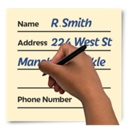
We might write some people’s answers in full with their names and addresses in the report or on the internet.

When you send us your answers, please tell us if you do not want us to write your name and address in the report or on the internet.

The data protection laws give you the right to:

- Know what information we have about you and how you can see it.

- Make us change any mistakes in the information about you.

- Ask us not to use the information in some cases.

- Ask us to delete the information we have about you in some cases.

- Move the information about you somewhere else in some cases.

- Complain to the Information Commissioner’s Office.
If you would like to know more about how your information is kept and used please contact us at:

Data Protection Officer
Welsh Government
Cathays Park
CARDIFF
CF10 3NQ
Email: Data.ProtectionOfficer@gov.wales

You can also contact the Information Commissioner’s Office:

Wycliffe House
Water Lane
Wilmslow
Cheshire
SK9 5AF
Tel: 01625 545745 or 0303 123 1113

Website: https://ico.org.uk
About you
Your name:

The organisation you are answering for or with:

Your email address:

Your address and phone number:

Do you want your answers to be shown on the internet and in a report?

Yes | ☐ |  | No | ☐

Questions
Question 1. Having 1 grant

Please read the section about Having 1 grant on pages 8 to 11.

Do you think that 1 overall grant would be better than 4 different grants?

Please think about how this may have an impact on students.

Yes | ☐ | No | ☐ | Not sure | ☐

Is there anything you want to say about this?

Question 2 - Study needs assessments

Please read the section about study needs assessments on pages 12 to 13.

Do you think a ready made package of support could work for students?

Please think about:
- If this would be good for students or not.

- Which types of disabilities we could support with a package of support.

- What we could include in packages of support for certain disabilities.
Yes | ☐ | No | ☐ | Not sure | ☐

Is there anything you want to say about this?
Question 3. Who should organise DSAs

Please read the section about who should organise DSAs on pages 14 to 17.

Should universities and colleges be responsible for:
- Study needs assessments?
- Non-medical help?
Yes | ☐ | No | ☐ | Not sure | ☐

Is there anything you want to say about this?

Question 4. Raising awareness

Please read the section about raising awareness on pages 18 to 19.

Do you think raising awareness of DSAs would help more people to get DSAs?

Yes | ☐ | No | ☐ | Not sure | ☐

Do you have any ideas for how we should do this?

Question 5. Anything else

Is there anything else you would like to say? If so please write it here:

Thank you.

