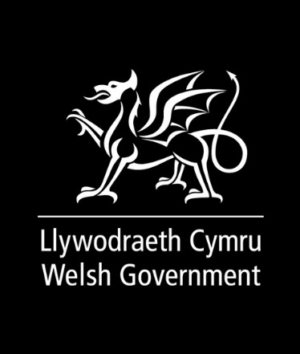
Easy Read
A Fairer Council Tax
Response Form
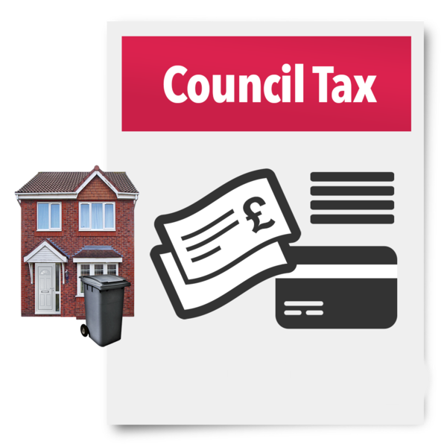

This document was written by the Welsh Government. It is an easy read version of ‘A Fairer Council Tax’.

June 2022

Questions

Changing the council tax bands
Please read pages 4 to 14 of the main document to answer questions 1, 2, 3 ,4 and 5.

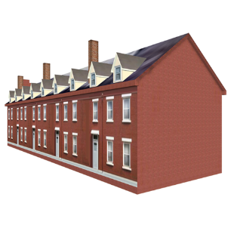
Question 1:
Do you think we should check house prices again to make sure people are charged fairly?

Yes ☐
No ☐
Please add any other comments here:

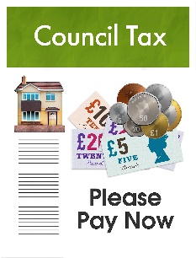
Question 2:
Do you think we should add more council tax bands?
Yes ☐
No ☐
Please add any other comments here:

Question 3:
The Welsh Government is thinking about making sure people who are affected have time to adapt to change. What do we need to think about?

Question 4:
Do you agree that the amount of money given to councils from the Revenue Support Grant will need to change?

For example, if councils get less money through council tax, should they get more money to keep paying for services.
Yes ☐
No ☐

Please add any other comments here:

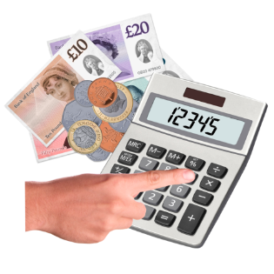
Question 5:
Do you think we need to check house prices regularly and make sure the amount of council tax people pay stays fair?
Yes ☐
No ☐

Please add any other comments here:

Changes to homes
Please read page 15 of the main document to answer question 6

Question 6:
Do you think we should check the council tax band when work is done on a home?
Yes ☐
No ☐
Please add any other comments here:

Appeals

Please read pages 16 and 17 of the main document to answer Question 7 and 8

Question 7:
What do you think about the rights people have to appeal? And how can we improve the way people appeal?

What do you think about council tax debt and how it is managed?

Information about council tax

Question 8:
What do you think about us working with others to improve the information people can get? And making the system easier to use?

Discounts and other rules for paying less council tax
Please read pages 18 to 20 of the main document to answer Questions 9, 10, 11 and 12.

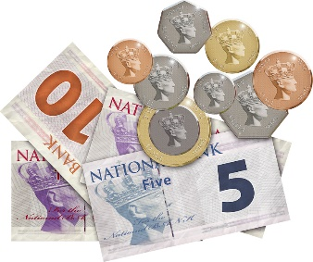
Question 9:
What do you think about the council tax discounts we have now? Do you think any of the rules around discounts need to change?

Question 10:
What do you think about the Welsh Government being able to change the council tax rules over things like:
- People living alone
- Empty Properties

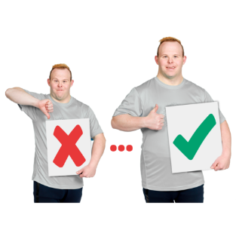
Question 11:
Could we change or improve the council tax discounts we have for disabled people?

Question 12:
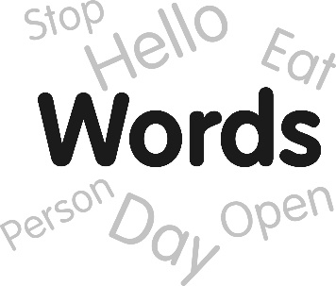
Should the government change any of the words used to describe people?

For example, the term severely mentally impaired is used at the moment.

This is a very old-fashioned term that can apply to lots of different groups of people. For example, people with some health conditions like dementia. Or people with a severe learning disability.

The Council Tax Reduction Scheme
Please read pages 21 to 23 of the main document to answer Question 13.

Question 13:
We will need to keep supporting people who do not have very much money.
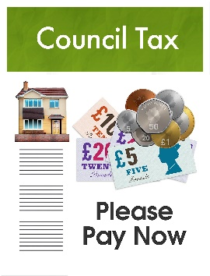
Do you have any views on how the Council Tax Reduction Scheme works? Do you think it should be means-tested?
Yes ☐
No ☐

Making changes when we need to
Please read pages 24 and 25 of the main document to answer questions 14 and 15.

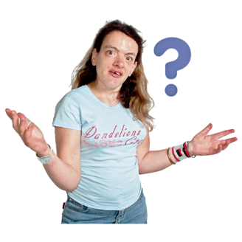
Question 14:
Do you think we should change the way the Council Tax Reduction Scheme is run, to allow Welsh Government to make changes to support people when needed?

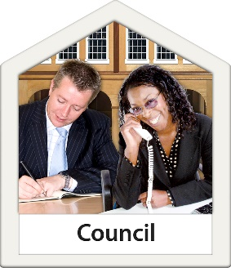
Question 15:
Should local councils be able to make some decisions?
What are your views about this?
Yes ☐
No ☐

The Welsh Language

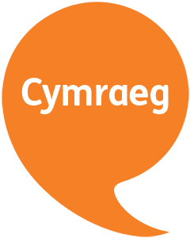
Question 16.
We would like to know if you think any of this work could have an effect on using the Welsh language.
Please tell us what you think here:

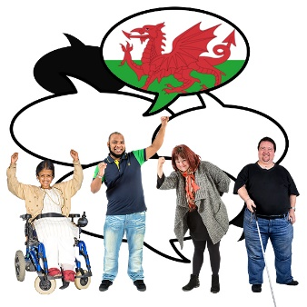
Question 17:
Do you think there is anything we can do to this work to make sure Welsh is treated the same as the English language?

Anything else
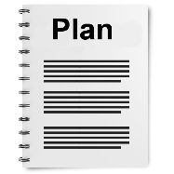
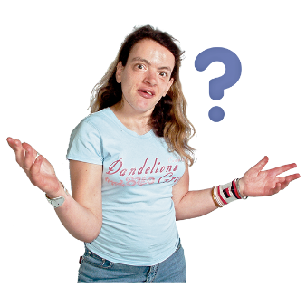
Question 18:
Is there anything else you would like to say about our plans? Please write them here.

How to respond
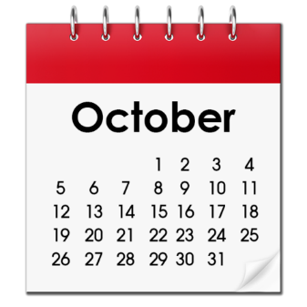
Send us your form by 12 o’clock midnight Monday 4 October 2022 in any of the following ways:

Email: LGFR.consultations@gov.wales

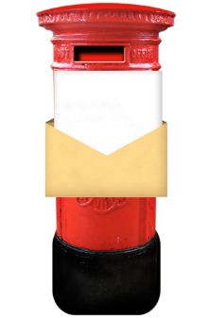
Post: Local Government Finance Reform Division
Local Government Directorate
Welsh Government
Cathays Park
Cardiff
CF10 3NQ

How we use your information
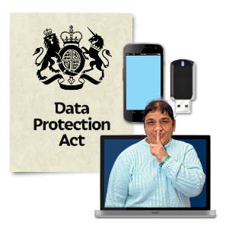
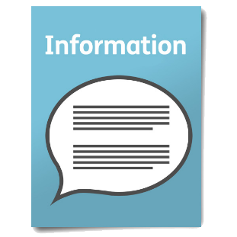
We use your information by following a law called UK General Data Protection Regulation (UK GDPR)

Our staff will be able to see your answers.
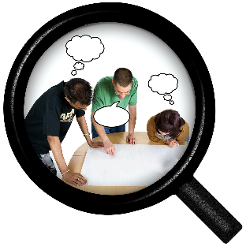
Sometimes we ask other organisations to help us understand people’s answers. So, they may see your information too.
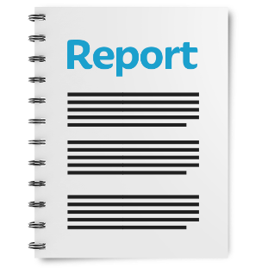
We normally publish a report showing the kinds of things people said.
Sometimes this means people’s personal details are included. Please tell us if you do not want your personal information included.

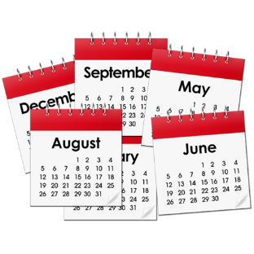
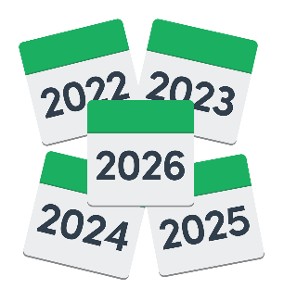
If you are in our report the information could be available for a long time.

But information that is not published is only kept for 3 years.

The data protection laws give you the right to:

- Know what information we have about you and how you can see it.
- Make us change any mistakes in the information about you.
- Ask us not to use the information in some cases.
- Ask us to delete the information we have about you in some cases.
- Move the information about you somewhere else in some cases.
- Complain to the Information Commissioner’s Office.

If you would like to know more about how your information is kept and used please contact us at:
Data Protection Officer
Welsh Government
Cathays Park
CARDIFF
CF10 3NQ

Email: Data.ProtectionOfficer@gov.wales

You can also contact the Information Commissioner’s Office:
Wycliffe House
Water Lane
Wilmslow
Cheshire
SK9 5AF

Tel: 01625 545745 or 0303 123 1113
Website: https://ico.org.uk

