Changes to Livestock Identification, Registration and Movement Reporting Consultation
Response Form

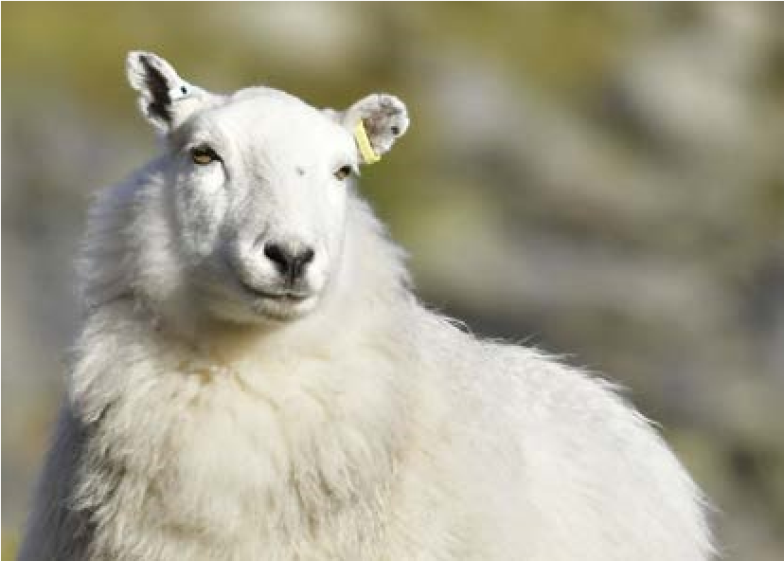
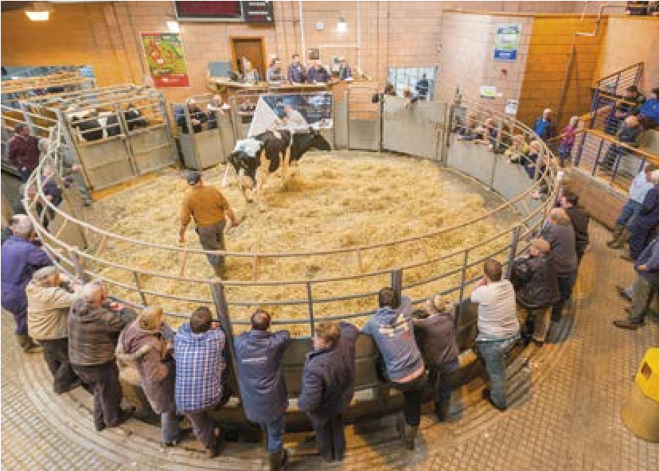
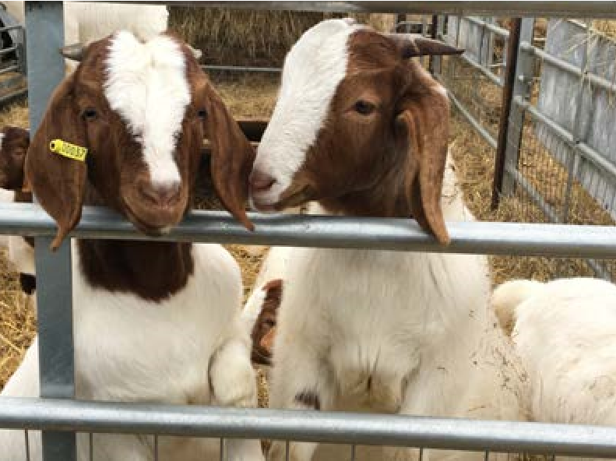
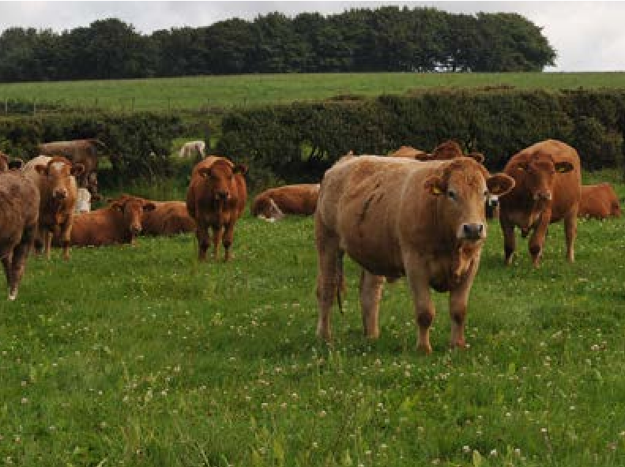
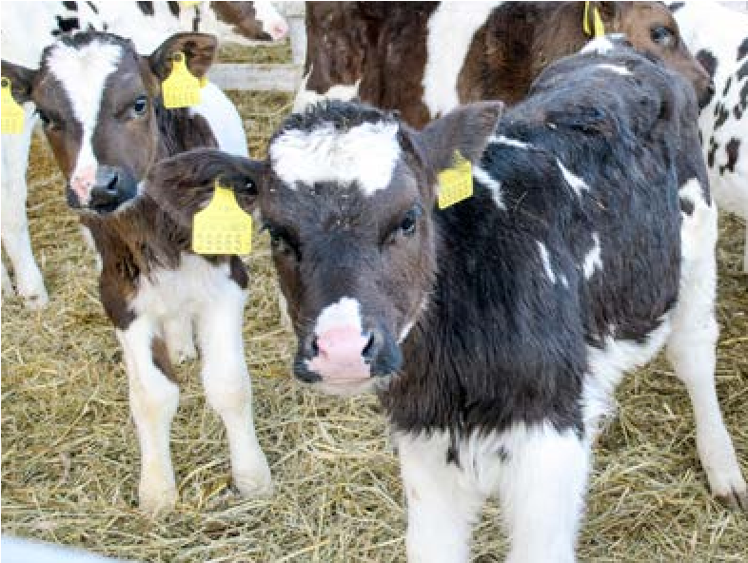
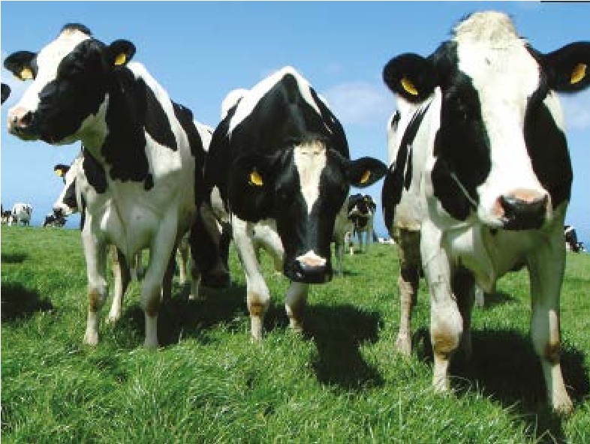
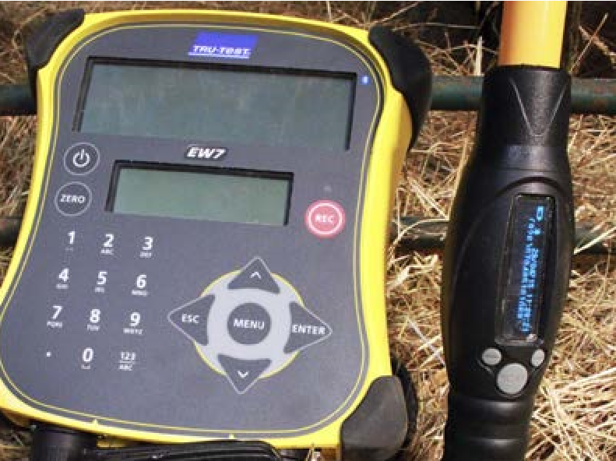
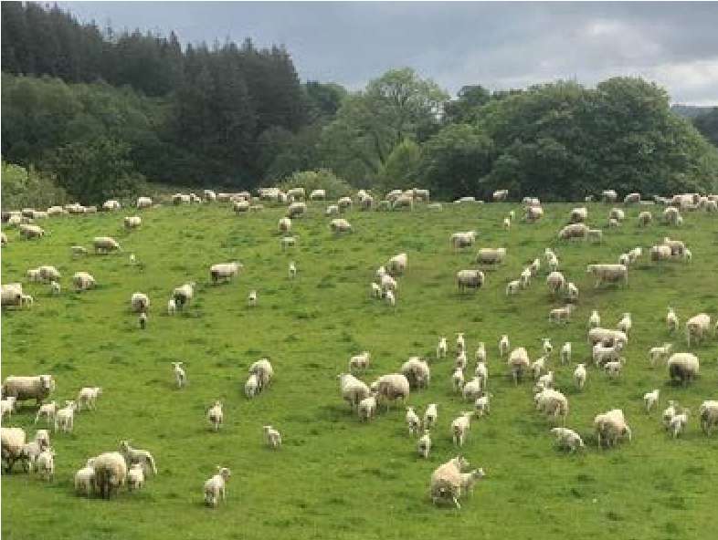
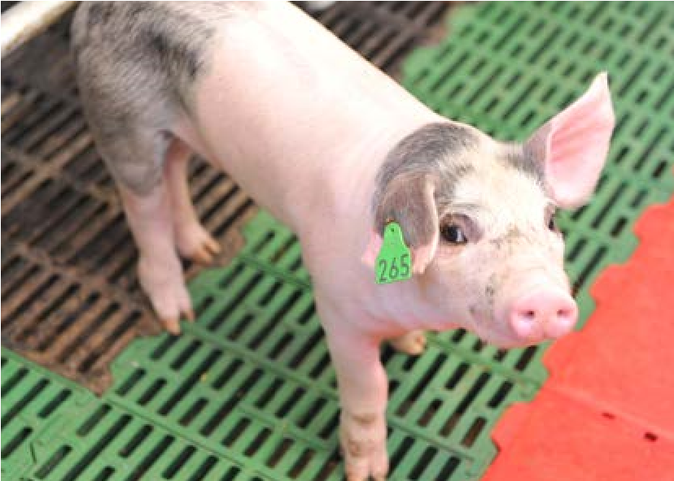
© Crown copyright 2021
WG43182 Mae’r ddogfen yma hefyd ar gael yn Gymraeg. This document is also available in Welsh.
Date of issue: 30 September 2021

Action required: Responses by 2 January 2022
This consultation is seeking views on the proposal to amend livestock identification, registration and movement reporting in Wales.

Name
Organisation (if applicable)
Email/telephone Number
Address
Consultation Response Form

Questions –
Section One – Mandatory whole movement reporting
1.1 | What are your views on the introduction of whole movement reporting for cattle?
1.2 | Are there any situations where it is not possible to record the destination CPH? If so, can any steps be taken so this information can be provided?
1.3 | Do you have any additional views on this?
Section Two – Mandatory journey information for all livestock
2.1 | Do you support the collection of the haulier and transport details for all livestock movements? Please provide reasons for your view.
2.2 | Are there any situations when you would not be able to provide all the journey details? Please provide examples.
2.3 | Do you have any additional views on this?
Section Three – Mandatory change to CPRC reporting timescales
3.1 | Do you agree with our aspiration to make CPRC same day reporting mandatory? Please provide your reasons for this?
3.2 | Do you have any additional views on this?
Section Four – Voluntary pre-movement reporting for all livestock
4.1 | Are there any situations where the current paper passport is still required?
4.2 | Are there any situations where the current paper AML1 is still required?
4.3 | Would you welcome the use of more digital services? What do you require in order to do this? E.g. training
4.4. | How do you currently report movements and why?
 | Cattle | Online | Paper | Telephone
 | Pigs | Online | Text | Telephone
 | Sheep | Online | Paper
 | Goats | Online | Paper
 | Deer | Online | Paper
 | Why?
4.5 | Do you have any additional views on this?
Section Five – Voluntary electronic reporting for all livestock
5.1 | Would you consider using EIDCymru as an electronic register instead of your paper flock book/herd book? What are your reasons for this?
5.2 | Do you agree with the introduction of paperless reporting for all livestock? What are the reasons for your views?
5.3 | Are there any reasons why you would want to continue to register births, deaths or report movements using paper forms?
5.4 | Do you agree with our proposal to reduce herd register timescales for reporting the birth of beef calves to 27 days? What are your reasons for this?
5.5 | Do you have any additional views on this?
Section Six – Voluntary show and event movement changes for all livestock
6.1 | What are your views on our proposal to allow exhibitors to create circular moves?
6.2 | Do you have any additional views on this?
Section Seven – Changes proposed for pig identification and traceability
7.1 | What are your views on the aspiration to make annual registration and an annual inventory for pigs mandatory?
7,2 | What do you think about the introduction of electronic tagging for pigs from when they leave their holding of birth? Do you think it should be made mandatory for breeding stock (gilts, sows and boars)?
7.3 | What are the benefits or potential obstacles to pig identification including the herd mark and unique ID number?
7.4. | Do you have any additional views on this?

Other Questions
8 | EIDCymru will be a fully bilingual service. We would like to know your views on the affects you think the extension of EIDCymru and introduction of Bovine EID could have on the Welsh language, specifically on opportunities for people to use Welsh and on treating the Welsh language no less favourably than English. What effects do you think there would be? How positive effects could be increased, or negative effects be mitigated?
9 | Please also explain how you believe the proposed policy options could be formulated or changed so as to have positive effects or increased positive effects on opportunities for people to use the Welsh language and on treating the Welsh language no less favourably than the English language, and no adverse effects on opportunities for people to use the Welsh language and on treating the Welsh language no less favourably than the English language.
10 | We have asked a number of specific questions. If you have any related issues which we have not specifically addressed, please use this space to report them.

Responses to consultations may be made public, on the internet or in a report. If you would prefer your response to be kept confidential, please tick here:
Consultation response form (continuation sheets)

Section & Question number:
Consultation response form (continuation sheets)

Section & Question number:
Consultation response form (continuation sheets)

Section & Question number:

