Easy Read

Funding for Equality and Inclusion Grant programme
Response form
Please send this response form back to us by 30 March 2021

This document was written by Welsh Government. It is an easy read version of Consultation on Future Funding for Equality and Inclusion Grant Programme.
15 February 2021
How to fill in this response form
 | These questions are about our ideas for the Funding for Equality and Inclusion Grant programme.
Before you answer the questions please read the main easy read document:
Funding for Equality and Inclusion Grant programme - What do you think about our plans for the future?
 | We want to know what you think. You can tell us by filling out this response form. Or you can tell us in a way that suits you better.
For example, you could send us your thoughts:
- in a video
- by recording yourself talking
- or by writing an e-mail.
 | Where the document says we, this means the Welsh Government.
 | This document was made into easy read by Easy Read Wales using Photosymbols.
 | Please send this form back to us by:
Post: The Equality Team
Welsh Government
Merthyr Tydfil
CF48 1UZ
 | E-mail: EandIFutureFundingConsultation@gov.wales
 | Please send your responses back by 30 March 2021.
How we will use the information you give us
 | We will be looking at your answers to make decisions about the Funding for Equality and Inclusion Grant programme.
 | Sometimes we ask other organisations to help us make decisions. They may also see the answers that people give.
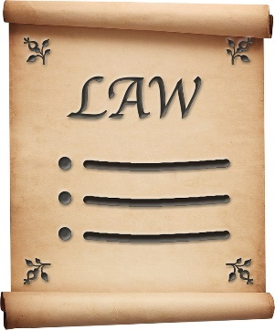 | We will make sure we follow the law when we use your information.
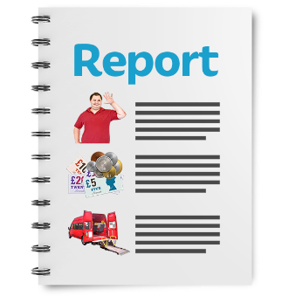 | We will write a report about what people said.
 | We might write some people’s answers in full with their names and addresses in the report or on the internet.
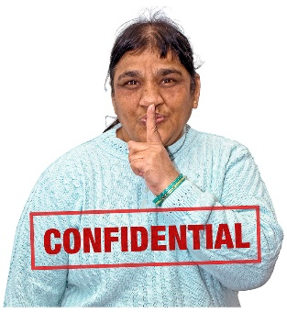 | When you send us your answers, please tell us if you do not want us to write your name and address in the report or on the internet.
 | The data protection laws give you the right to:
 | - know what information we have about you and how you can see it
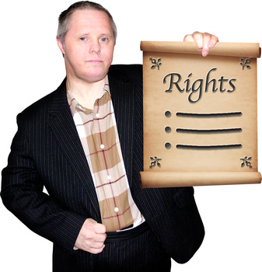 | - make us change any mistakes in the information about you
 | - ask us not to use the information in some cases
 | - ask us to delete the information we have about you in some cases
 | - move the information about you somewhere else in some cases
 | - complain to the Information Commissioner’s Office.
 | If you would like to know more about how your information is kept and used please contact us at:
Data Protection Officer
Welsh Government
Cathays Park
Cardiff
CF10 3NQ
 | E-mail: Data.ProtectionOfficer@gov.wales

Questions
 |  | Your name:
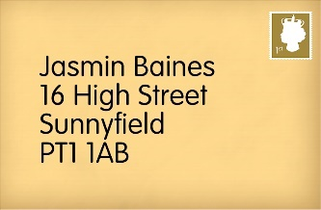 |  | Your home address:
 |  | Your e-mail address:
 |  | Your phone number:
 |  | Welsh Government may publish some of the information you send us. This means anyone can read it. We might include your name and address.
 |  | Please tick here if you do not want us to publish your name and address. |  | ☐
 | - Do you think it is a good idea for us to make plans to carry on supporting equality and inclusion in Wales over the next 5 years?
 | Yes ☐ No ☐ Unsure ☐
 | - Do you think it is a good idea to make sure the organisations we support share our values about equality and inclusion?
 | Yes ☐ No ☐ Unsure ☐
 | - Do you think we should ask organisations to show us how they will be supporting equality and inclusion in Wales?
 | Yes ☐ No ☐ Unsure ☐
 | - Do you think it is important to support people who are treated unfairly because of where they live and how much money they have?
 | Yes ☐ No ☐ Unsure ☐
 | - Do you think it is important for organisations to work together to support people who are treated unfairly for more than one reason?
 | Yes ☐ No ☐ Unsure ☐
- Do you think it is important for us to keep funding organisations who support people who are treated unfairly because:
- They are Black, Asian or ethnic minority
- They are a woman or because they are a man
- They are LGBTQ+
 | Yes ☐ No ☐ Unsure ☐
 | - Do you think it is important for us to keep funding some of the organisations who have shown us how helpful their work is?
 | Yes ☐ No ☐ Unsure ☐
 | - Do you think it is important for us to work closely with the teams who are supporting equality and inclusion in local communities?
 | Yes ☐ No ☐ Unsure ☐
 | - Is there anything else you would like to say about equality and inclusion in Wales?
Thank you.

