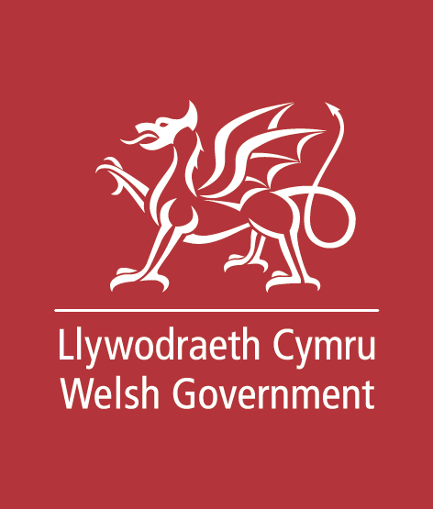

Mae’r ddogfen yma hefyd ar gael yn Gymraeg.

This document is also available in Welsh.

 © Crown Copyright

Welsh Government

Consultation Question and Response Form

Date of issue: 18 January 2021

Action required: Responses by 9 April 2021

A pathway and next steps for developing the hydrogen energy sector in Wales

Hydrogen in Wales



**Number: WG41823**

# Questions and Consultation Response Form

|  |  |
| --- | --- |
| **Consultation Response Form** | Your name:  Organisation (if applicable):  email / telephone number:  Your address: |

**Questions**

|  |  |
| --- | --- |
| Strategic Vision | |
| 1 | Public and private sector representatives are developing a hydrogen pathway for Wales based on evidence that hydrogen will be required to play a part in the future energy mix if we are to meet our climate change aspirations.  Do you agree this activity is needed to ensure Wales is well positioned to take advantage of potential opportunities arising from use of hydrogen? If not, why? Do you have any evidence to support these views?   |  | | --- | |  | |
| 2 | Why are you supportive/not supportive of Wales pursuing hydrogen opportunities?  If supportive, what actions can you / your organization, take to contribute towards the development of the hydrogen sector in Wales (and under what conditions)?   |  | | --- | |  | |
| 3 | Do you have any evidence on the best sources of energy for low carbon / renewable hydrogen production? Should Wales seek to generate hydrogen within the country or seek import opportunities, or pursue both options?   |  | | --- | |  | |
| 4 | In your view, does the proposed hydrogen pathway complement on-going and planned hydrogen initiatives across the UK? What other actions should be considered in the hydrogen pathway that would further distinguish Wales, or support other UK activities? Do you have any evidence to support these views which you can share?   |  | | --- | |  | |
| Hydrogen Pathway Scope | |
| 5 | Are there other areas where you believe hydrogen and fuel cell technologies have a role to play in Wales in the short term (period to 2025)?   |  | | --- | |  | |
| 6 | Do you believe the pathway strikes the right balance between being ambitious yet proposing actions which can be delivered?   |  | | --- | |  | |
| Hydrogen Pathway Delivery | |
| 7 | In addition to the points set out in the objectives, are there any other “no regrets” actions that you believe Welsh Government / industry should take in the short term to develop the hydrogen sector in Wales? Do you have evidence you can share in support of that view?   |  | | --- | |  | |
| 8 | What are the key barriers, risks and challenges to realise the opportunities described? In your view, what measures would help to overcome these and what are the key enabling factors?   |  | | --- | |  | |
| Welsh Language Considerations | |
| 9 | We would like to know your views on the effects that ‘Hydrogen in Wales’ and the next steps for developing the hydrogen energy sector in Wales would have on the Welsh language, specifically on opportunities for people to use Welsh and on treating the Welsh language no less favourably than English. What effects do you think there would be? How could positive effects be increased, or negative effects be mitigated?   |  | | --- | |  | |
| 10 | Please also explain how you believe the proposed opportunities could be formulated or changed so as to have positive effects or increased positive effects on opportunities for people to use the Welsh language and on treating the Welsh language no less favourably than the English language, and no adverse effects on opportunities for people to use the Welsh language.   |  | | --- | |  | |
| Summary | |
| 11 | If you have any related comments which we have not specifically addressed in this consultation, please respond under question 11, supported by any relevant evidence.   |  | | --- | |  | |

Responses to consultations are likely to be made public, on the internet or in a report.  If you would prefer your response to remain anonymous, please put a

cross here: