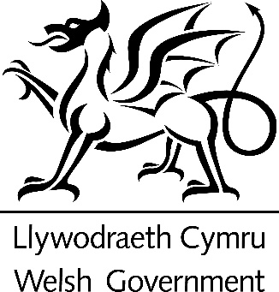
Easy Read

How councils should understand how well they are doing and improve
Response form
Please send this response form back to us by 3 February 2021

This is an easy read version of the questions from the Welsh Government consultation on “Draft Statutory Guidance. Performance and governance of principal councils”.

December 2020
How to fill in this response form
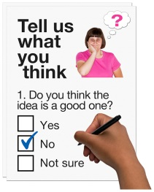
These questions are about our ideas for the guidance on Chapter 6, Part 1 of the Local Government and Elections (Wales) Bill.

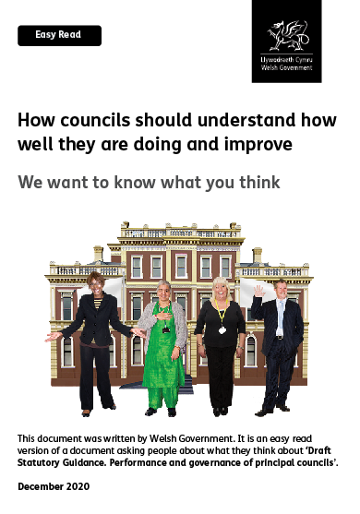
Before you answer the questions please read the main easy read document:

How councils should understand how well they are doing and improve - We want to know what you think

Please try to explain your answers. And give your own thoughts and ideas too.

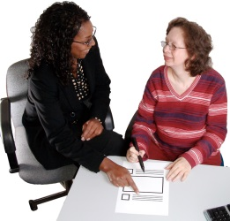

You may need support to read and understand this document. Ask someone you know to help you.

Some words may be difficult to understand. These are in bold blue writing. They have been explained on page 24 of the main document.

Where the document says we, this means the Welsh Government.

This document was made into easy read by Easy Read Wales using Photosymbols.

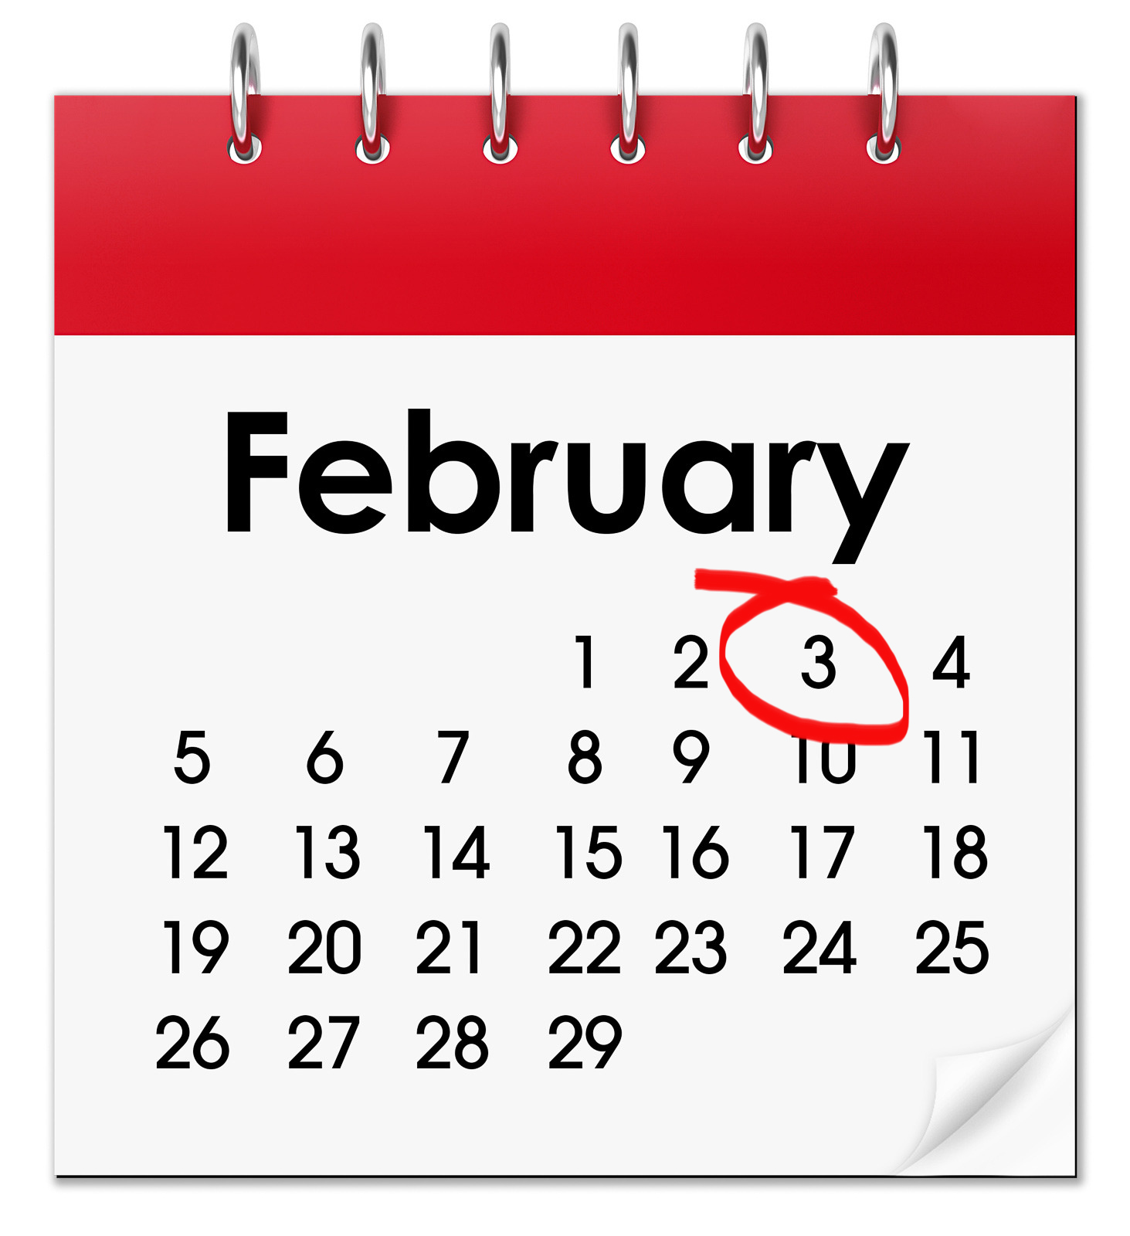

Please send this form back to us by 3 February 2021

By post:
Local Government Transformation & Partnerships Division
Local Government Directorate
Welsh Government
Cathays Park
Cardiff
CF10 3NQ
By email: lgpartnerships@gov.wales

How we will use the information you give us
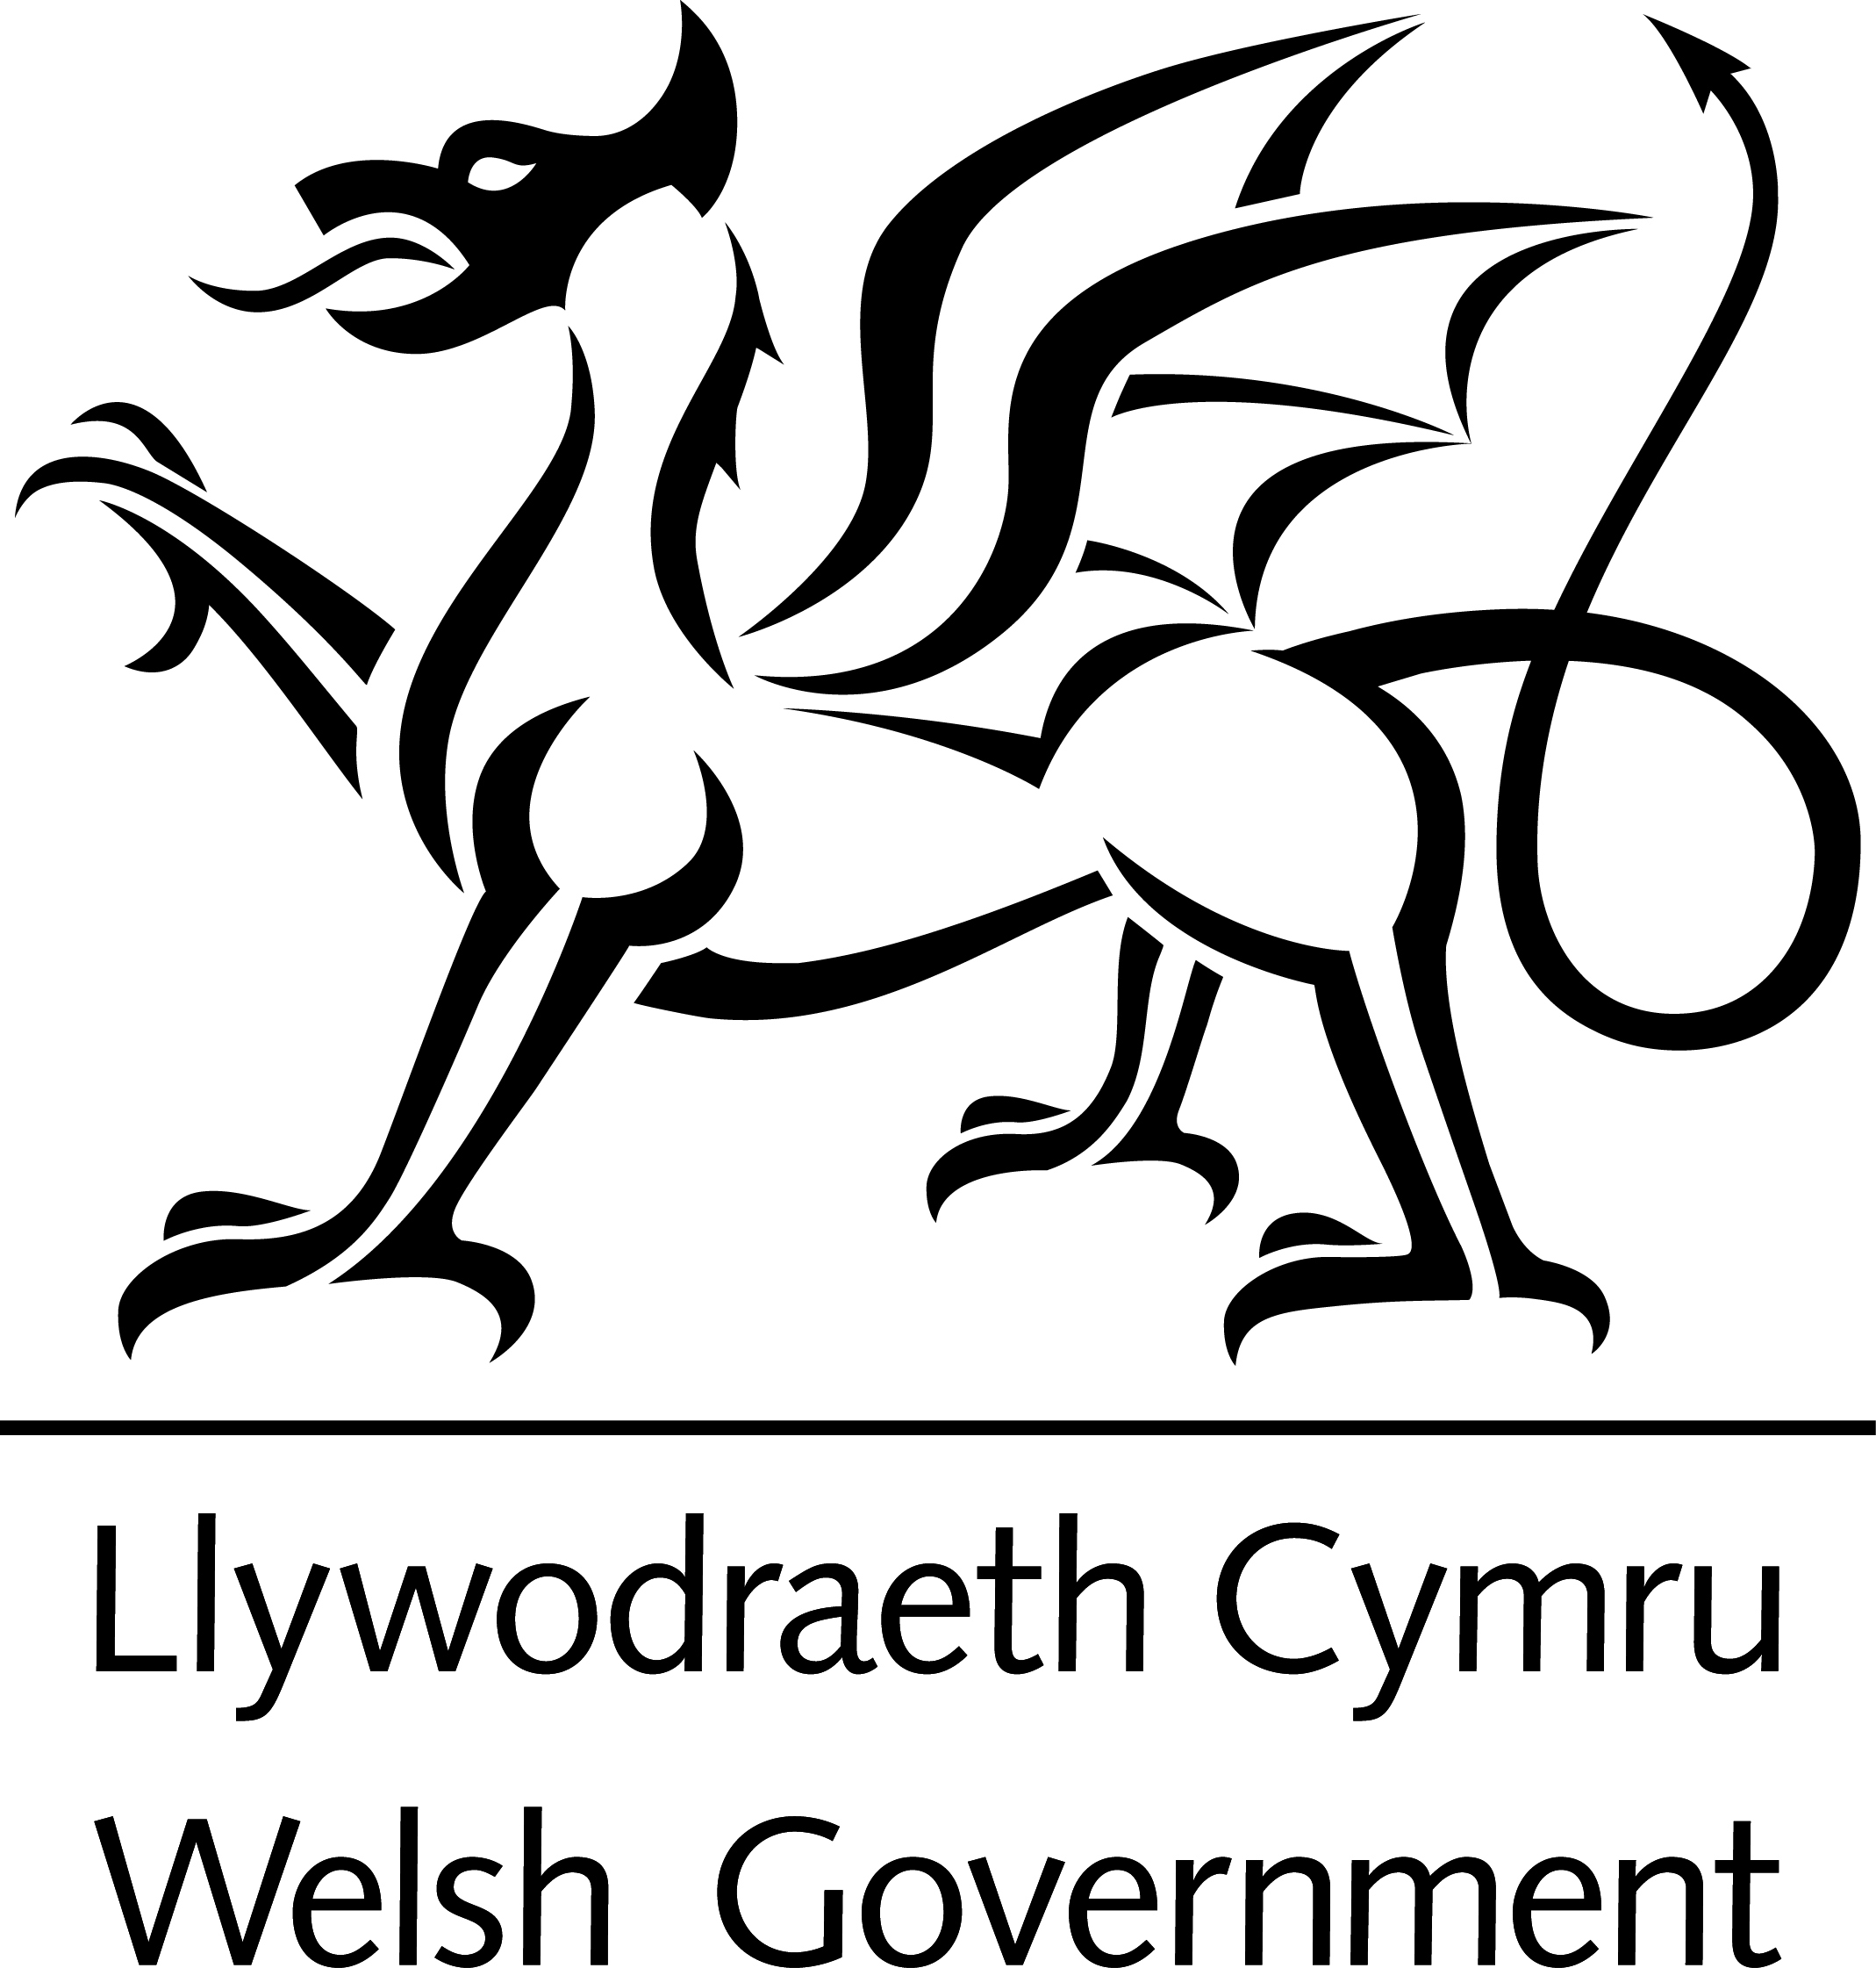
Welsh Government will be looking at your answers to make decisions about the guidance for Part 6, Chapter 1, of the Local Government and Elections (Wales) Bill.

Sometimes we ask other organisations to help us make decisions. They may also see the answers that people give.

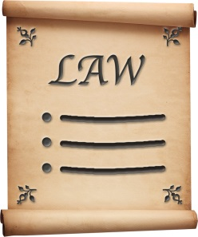
We will make sure we follow the law when we use your information.

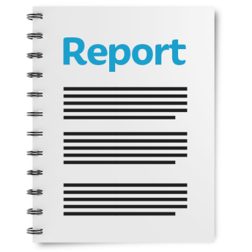

We will write a report about what people said.

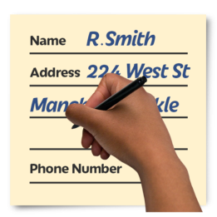
We might write some people’s answers in full with their names and addresses in the report or on the internet.
When you send us your answers, please tell us if you do not want us to write your name and address in the report or on the internet.

The data protection laws give you the right to:

- know what information we have about you and how you can see it

- make us change any mistakes in the information about you

- ask us not to use the information in some cases

- ask us to delete the information we have about you in some cases

- move the information about you somewhere else in some cases

- complain to the Information Commissioner’s Office.

If you would like to know more about how your information is kept and used please contact us at:

Data Protection Officer
Welsh Government
Cathays Park
Cardiff
CF10 3NQ

email: Data.ProtectionOfficer@gov.wales

You can also contact the Information Commissioner’s Office:

Wycliffe House
Water Lane
Wilmslow
Cheshire
SK9 5AF

Tel: 01625 545745 or 0303 123 1113

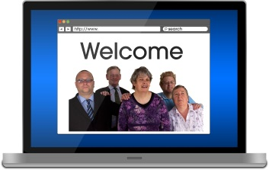
Website: https://ico.org.uk
Questions

Question 1. Do you think the guidance explains clearly what the law – Part 6, Chapter 1 of the Local Government and Elections (Wales) Bill - expects councils to do?
Yes | ☐ | No | ☐ | Not sure | ☐

If not, please tell us why not:

Question 2. Please read pages 14 to 15. Do you think Chapter 2 makes it clear that councils should keep checking what they do?

Yes | ☐ | No | ☐ | Not sure | ☐

If not, what would you add or change?

Question 3. Please read pages 14 to 15. Do you think Chapter 2 explains clearly how councils could do self-assessments?

Yes | ☐ | No | ☐ | Not sure | ☐

If not, what would you add or change?

Question 4. Please read pages 16 to 19. Do you think Chapter 3 explains clearly how councils could do panel performance assessments?

Yes | ☐ | No | ☐ | Not sure | ☐

If not, what would you add or change?

Question 5. Please read pages 20 to 22. Chapter 4 is about the role of the Auditor General for Wales. Chapter 5 is about what Welsh Ministers and councils can do.

Do you think Chapter 4 and Chapter 5 clearly explains what the Auditor General for Wales, councils and Welsh Ministers can do?

Yes | ☐ | No | ☐ | Not sure | ☐

If not, what would you add or change?

Question 6. Do you think the guidance would have an effect on the Welsh language?
For example, will the guidance give people more chances to use Welsh? Do you think the Welsh and English languages will be treated equally?

Yes | ☐ | No | ☐ | Not sure | ☐

Question 7. How could we make sure the guidance has a good impact on the Welsh language? How could we stop there being a bad impact? If you have any thoughts about this, please tell us here:

Question 8. Is there anything else you would like to say about the draft guidance?

Please tell us here:

Your personal details
Your name:

Your organisation:

Your email address:

Your address / telephone number

If you do not want us to write your answers, your name and address in our report, or on the internet, please tick here ☐

Thank you.

