
Easy Read

Equal Wales
What should we do to make Wales a fairer place to live and work? 2020-2024
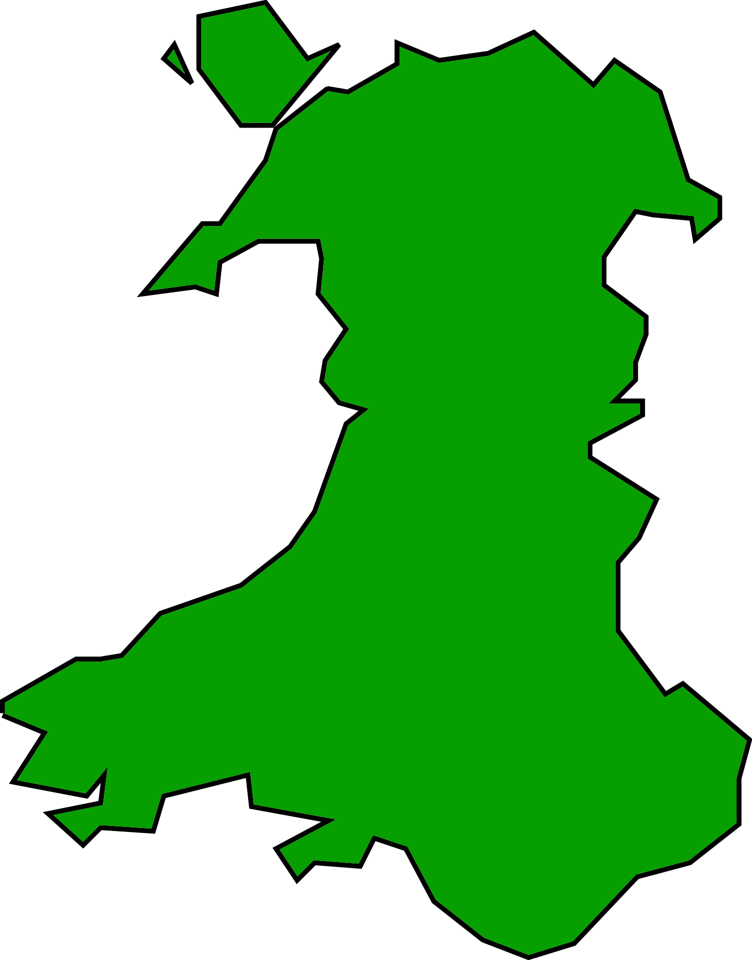

Response Form

Please tell us what you think by 19 November 2019

This is an easy read version of the questions from Welsh Government Strategic Equality Objectives 2020 – 2024 Consultation.
September 2019

About this response form
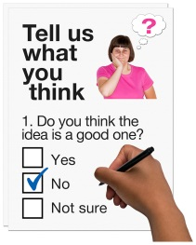
These questions are about our ideas for making Wales a fairer place to live and work.

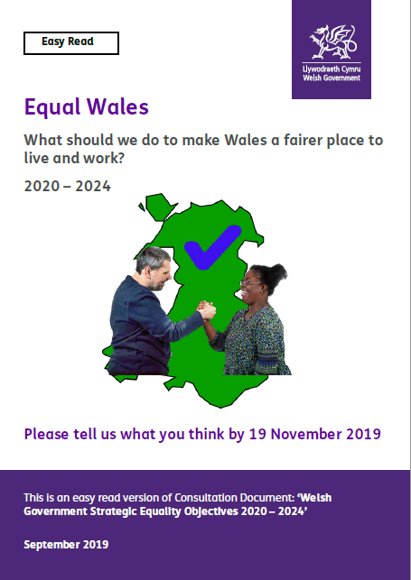
Before you answer the questions, please read the main easy read document: ‘Equal Wales – What should we do to make Wales a fairer place to live and work? 2020-2024’.



Please try to explain your answers. And give your own thoughts and ideas too.

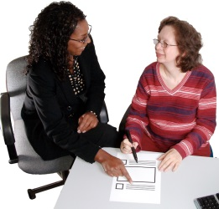
You may need support to read and understand this document. Ask someone you know to help you.



Where the document says we, this means the Welsh Government.

Please send this form back to us by 19 November 2019.

By post:
Equality Team
Communities Division
Welsh Government
Cathays Park
Cardiff
CF10 3NQ


By e-mail:
StrategicEqualityPlanObjectives2020@gov.wales


The response form is also on our website: https://gov.wales/consultations

How we use the information you give us

Welsh Government will be looking at your answers in this response form to make decisions about how to support people in the best way.

Sometimes we ask other organisations to help us make decisions. They may also see the answers that people gave in the response forms.
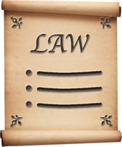

We will make sure we follow the law when you use your information.
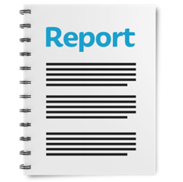

We will write a report about what people said.

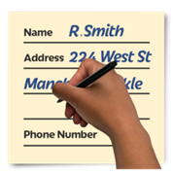
We might write some people’s answers in full with their names and addresses in the report or on the internet.

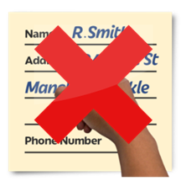
When you send us your answers, please tell us if you do not want us to write your name and address in the report or on the internet.

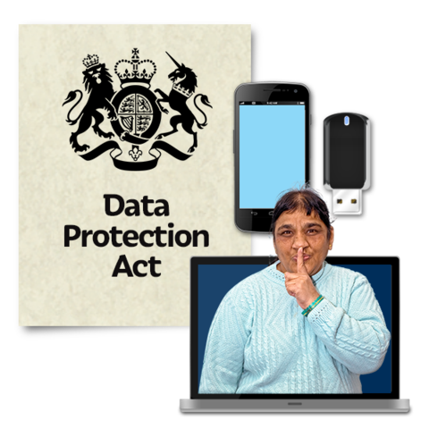
The data protection laws give you the right to:
- Know what information we have about you and how you can see it.

- Make us change any mistakes in the information about you.

- Ask us not to use the information in some cases.

- Ask us to delete the information we have about you in some cases.

- Move the information about you somewhere else in some cases.

- Complain to the Information Commissioner’s Office.

If you would like to know more about how your information is kept and used please contact us at:
Data Protection Officer
Welsh Government
Cathays Park
CARDIFF
CF10 3NQ


Email: Data.ProtectionOfficer@gov.wales

You can also contact the Information Commissioner’s Office:

Wycliffe House
Water Lane
Wilmslow
Cheshire
SK9 5AF

Tel: 01625 545745 or 0303 123 1113

Website: https://ico.org.uk

About you
Your name:

The organisation you are answering for or with:

Your email address:

Your address and phone number:

Do you want your answers to be shown on the internet and in a report?

Yes | ☐ |  | No | ☐

Questions

- Do you agree with our Equality Objectives on Page 17 - 18?
Yes | ☐ | No | ☐ | Not sure | ☐

If you said no please tell us why not:

- Do you think there is something missing from our Equality Objectives?
Yes | ☐ | No | ☐ | Not sure | ☐

If you said yes please tell us what you think is missing:

- What problems with fairness do you think we should deal with first in Wales?

- Do you think it is a good idea to say what we will do to achieve our Equality Objectives?
Yes | ☐ | No | ☐ | Not Sure | ☐

If you said no please tell us why not:

- Do you think our Equality Objectives will change things for people speaking Welsh?
Yes | ☐ | No | ☐ | Not Sure | ☐

Please explain why you think this:

- How could we change our Equality Objectives to give more people more chances to speak Welsh?

- Is there anything else you would like to say? If so please write it in the box below.

