Easy Read

Changing Places Toilets and Baby Nappy Changing Places
Our ideas to get more of these facilities in public buildings
Response Form
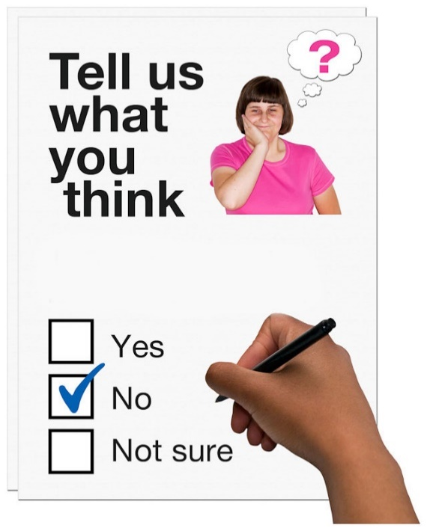

This is an easy read version of Welsh Government’s
‘Draft Policy Changes - Changing Places Toilet and Baby Nappy Changing Provision’ – Consultation Document.
February 2021
How to fill in this response form
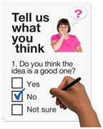 | These questions are about our ideas for having more Changing Places Toilets and Baby Nappy Changing Places.
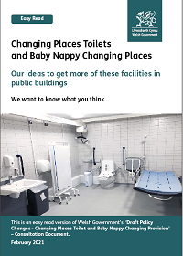 | Before you answer the questions, please read the main easy read document: Changing Places Toilets and Baby Nappy Changing Places - Our ideas to get more of these facilities in public buildings
 | Where the document says we, this means the Welsh Government.
By post:
Changing Places Toilets/Baby Nappy Changing
Building Regulations
Welsh Government
Cathays Park
Cardiff, CF10 3NQ
 | By e-mail: enquiries.brconstruction@gov.wales
 | If you have any questions about this consultation, please contact us:
 | By e-mail: enquiries.brconstruction@gov.wales
 | Or phone: 0300 062 8144
 | This form was made into easy read by Easy Read Wales using Photosymbols.

How we use the information you give us
 | The Welsh Government will be looking at your answers in this response form.
 | Sometimes we ask other organisations to help us make decisions. They may also see the answers that people give in the response forms.
 | We will make sure we follow the law when we use your information.
 | We will write a report about what people said.
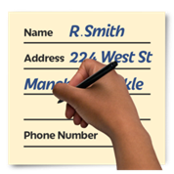 | We might write some people’s answers in full with their names and addresses in the report or on the internet.
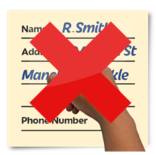 | When you send us your answers, please tell us if you do not want us to write your name and address in the report or on the internet.

The data protection laws give you the right to:

- Know what information we have about you and how you can see it.
- Make us change any mistakes in the information about you.
- Ask us not to use the information in some cases.
- Ask us to delete the information we have about you in some cases.
- Move the information about you somewhere else in some cases.
- Complain to the Information Commissioner’s Office.

If you would like to know more about how your information is kept and used please contact us at:

Data Protection Officer
Welsh Government
Cathays Park
CARDIFF
CF10 3NQ

Email: Data.ProtectionOfficer@gov.wales

You can also contact the Information Commissioner’s Office:

Wycliffe House
Water Lane
Wilmslow
Cheshire
SK9 5AF
Tel: 01625 545745 or 0303 123 1113

Website: https://ico.org.uk

Your personal details
Your name:

If you are answering on behalf of an organisation please tell us who they are:

Your email address:

Your address and phone number:

If you do not want us to share your answers in a report or on the internet, please tick this box: |  | ☐

I am (Please tick 1)
A Builder or Developer | ☐
A Manufacturer | ☐
Designer, Engineer or Surveyor | ☐
Local Authority Building Control | ☐
Approved Inspector Building Control | ☐
An Access Consultant | ☐
An Occupational Therapist | ☐
From a Disabled People’s Organisation | ☐
A Facilities Manager | ☐
A Retailer | ☐
A Construction Professional | ☐
A Property Manager or Landlord | ☐
From a Landlord Representative Organisation | ☐
A Changing Places User or Carer | ☐
A Parent or Carer | ☐
From a Charity | ☐
A Campaigner or from a Lobby Group | ☐
Other, please say what: | ☐

 | Questions about Changing Places Toilets
- Do you agree that we should have more Changing Places Toilets in public places?
 |  | Yes | ☐
 |  | No | ☐
 |  | Not sure | ☐
 |  | Please tell us why you think this:

- Do you think we should change the building regulations guidance, to make sure builders and planners think about Changing Places Toilets?

 | Yes | ☐
 | No | ☐
 | Not sure | ☐
 | If you said no, please tell us why:

- Do you think we should use Planning Policy Wales to help local authorities make sure there are enough Changing Places Toilets in their areas?
 | Yes | ☐
 | No | ☐
 | Not sure | ☐
 | Please tell us why you think this:

- Do you agree that the types of buildings listed in BOX A on page 13 of the main document, should have a Changing Places Toilet?
 | Yes | ☐
 | No | ☐
 | Not sure | ☐
 | If you said no, please tell us why:
 | Are there any other buildings you thinks should also have Changing Places Toilets? Please tell us here.
 | Do you think some buildings in BOX A should not have Changing Places Toilets? Please tell us here.

- Do you think any different types of schools should have Changing Places Toilets?
Yes | ☐
No | ☐
Not sure | ☐
If so, which ones and why?

- Please read page 13 of the main document.
Do you agree that the following types of new buildings or existing buildings being extended should have Changing Places Toilets if:
- they are very large (over 5000 square metres in size)
- or they can have over 1,000 people in them?
 | I agree | I do not agree | I’m not sure
Shopping centres | ☐ | ☐ | ☐
Large shops | ☐ | ☐ | ☐
Sports and leisure centres | ☐ | ☐ | ☐
Hospitals and community care centres | ☐ | ☐ | ☐
Buildings used for entertainment or meetings. | ☐ | ☐ | ☐
A hotel that is open to public events | ☐ | ☐ | ☐
Schools that are open to the community | ☐ | ☐ | ☐

Our idea is that certain buildings should have changing places toilets when:
- They are very large (over 5000 square metres in size)
or
- can hold 1000 people or more.

Do you think there are any other things that should trigger a building getting a Changing Places Toilet? Do you think the size or number of people should be different?

- Do you agree that Changing Places Toilets in new buildings, should have the equipment listed on page 15 of the main document?
 | Yes | ☐
 | No | ☐
 | Not sure | ☐
 | Please tell us if we need to have more equipment, or if we do not need any of the equipment listed:

- If a Changing Places Toilet is being put in an existing building, where they may not be as much space, what kind of equipment do you think it should have?
- If you want to say anything more about our ideas for having more Changing Places Toilets, including about how big they should be and what equipment they should have, please write here:

Questions about Baby Nappy Changing places
- Do you agree that we should have more Baby Nappy Changing Places in public places?
 | Yes | ☐
 | No | ☐
 | Not sure | ☐
 | Please tell us why you think this:

 | - Do you agree that the types of buildings listed in BOX B on page 18 of the main document should have Baby Nappy Changing places?
 |  | Yes |  | ☐
 |  | No |  | ☐
 |  | Not sure |  | ☐
 |  | If you said no, please tell us why:
 |  | Are there any other buildings you think should also have a Baby Nappy Changing place? Please tell us here:
 |  | Do you think any of the buildings listed in BOX B should not have Baby Nappy Changing Place? Please tell us here:
- Please read page 18 of the main document.
Do you agree that the following types of new buildings, or buildings being extended, should have Baby Nappy Changing Places?
 |  |  | I agree |  | I do not agree |  | I do not know
Big shops or shopping centre |  |  | ☐ |  | ☐ |  | ☐
Meeting places that can have over 200 people |  |  | ☐ |  | ☐ |  | ☐
Entertainment places, restaurants or places that can have over 200 people |  |  | ☐ |  | ☐ |  | ☐
A hospital with waiting area |  |  | ☐ |  | ☐ |  | ☐
A hotel that is opened to public events |  |  | ☐ |  | ☐ |  | ☐
Schools that are open to the community |  |  | ☐ |  | ☐ |  | ☐

Our idea is that certain buildings should have baby nappy changing places when:
- They are very large (over 1000 square meters)
- or can hold 200 people or more.

Do you think there are any other things that should trigger a building getting a nappy changing place? Do you think the size or number of people should be different?

- Do you agree that Baby Nappy Changing Places should have the equipment listed in BOX C on page 20 of the main document?
 | Yes | ☐
 | No | ☐
 | Not sure | ☐
 | Please tell us if we need to have more equipment, or if we do not need any of the equipment listed:

- Do you agree with how much we think it will cost to provide Nappy Changing Places and Changing Places Toilets?
 | Yes | ☐
 | No | ☐
 | Not sure | ☐
 | If you said no, what costs do you think need to be added or removed?

- Do you think our new ideas would have an impact on the Welsh language? For example, will they give people a chance to use the Welsh language more or less?
 | Yes | ☐
 | No | ☐
 | Not sure | ☐
 | - How do you think we could change our plans to make it easier for people to use the Welsh language?

Thank you

